The transistor

Joel Sanz Martí – 2º CFGS

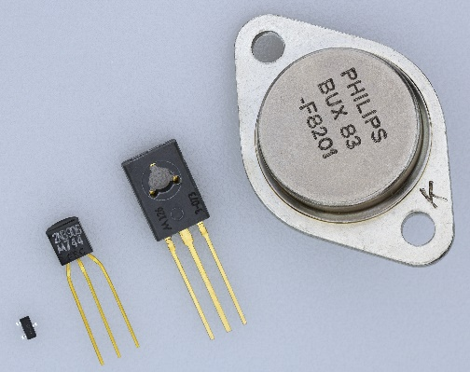A transistor is a semiconductor device used to amplify or switch electrical signals and power. Transistors are composed of semiconductor materials, mostly made from very pure silicon, and some from germanium.

In 1947, experiments were performed by John Bardeen and Walter Brattain, in which they observed that when two gold point contacts were applied to a crystal of germanium, a signal was produced with the output power greater than the input.

Later in the same year, the knowledge about semiconductors was greatly expanded by William Shockley. Then, the term “transistor” was set by John R. Pierce as a contraction of “transresistance”.

As it has been already said, transistors have two main uses. On the one hand, they’re used in digital circuits as electronic switches. In this field, the MOSFET is by far the most used transistor. On the other hand, they’re used as common-emitter amplifiers in various configurations, such as current gain or voltage gain.

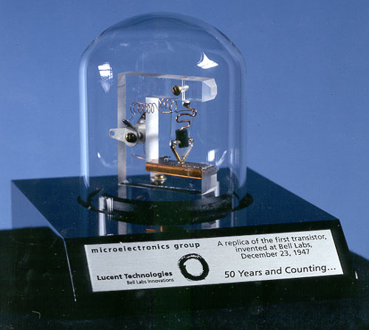

A replica of the first working transistor